**The Grill House - Restaurant Management System**

***Simplilearn Project for Capstone***



**Submitted by:** Moshay

**Table of Content**

**Project Tasks**  3

**Project Overview:** 4

**Requirement Classification Schema:** 5

**Knowledge Areas Implementation:** 6

**Techniques:** 11

**Process Analysis** 11

**Process Modelling** 12

**Scope Modelling** 13

**Data Modelling:** 14

**Activity Diagram** 15

**Prototyping** 15

**Swimlane Activity Diagram** 18

**Wireframe for the Online Restaurant Management System** 20

#### **Product Backlog** 22

## Project Tasks

|  |  |  |
| --- | --- | --- |
| **S No.** | **Tasks** | **References** |
| 1. | Identifying stakeholders – Create a list of stakeholders (as taught in Business Analysis Planning and Monitoring Knowledge Area) | * Figure 1: Stakeholder Map via Stakeholder Matrix * Table 3: Applied BA Knowledge Areas |
| 2. | Identify the problem statement in this system | * Table 1: BACCM |
| 3. | Identify objectives of the new Restaurant Management System | * Table 1: BACCM |
| 4. | Create as-is and future process map (using flowcharts) | * Figure 4: Current State Process * Figure 5: Future State Process |
| 5. | As a Business Analyst working on this project, find out the scope of the Restaurant Management System. To find the scope you can use the case diagram (UML) or context diagram for the same. | * Figure 6: Process Modelling using Use case Diagram (UML) |
| 6. | Write down the main features that need to be developed. | * Table 4: High-level Components that needs to be built |
| 7. | Write the in-scope and out-of-scope items for this software. | * Table 5: Product In-scope & Out of Scope |
| 8. | Draw an activity diagram for the system. | * Figure 9: Activity Diagram for Waiters/Managers |
| 9. | Draw an ER diagram of the system. | * Figure 8: Data Modelling using ER Diagram |
| 10. | Write out the business requirements, both the functional and nonfunctional requirements. | * Table 2: Requirement Classification Schema |
| 11. | Draw wireframes or mock screens for any two of the features namely Menu Creation and any other feature as deemed fit by the student. | * Figure 10: Waiter order creation Mock screens * Figure 11: Menu Creation Mock screens |

## Project Overview:

Captured below is the Project Objective using the **Business Analysis Core Concept Model (BACCM)**

*Table 1: BACCM*

|  |  |
| --- | --- |
| **Business Need / Problem Statement** | The Grill House is a large chain of restaurants across different cities in the USA. It is owned by a US celebrity chef James Oliver. The chain of restaurants sales trends and performance are managed manually by each restaurant. The bills are paper-based and all the sales information is manually entered at the end of day. This is a decentralized day-to-day management of the restaurants.  Following are the challenges the Employees run into during daily management of the restaurant chains:   * Manual paper-based system. * Orders are taken by the waiters on paper and paper-based bill is given to customer. * Time consuming as bills are entered into an excel sheet by the manager at EOD. * Restaurants cannot easily update their menu. * Cannot easily search the dishes on the menu. * Not able to recognize different types of users such as managers, waiters, etc. |
| **Change** | * An automated restaurant management system that could save waiters and managers time. * Improved service to the customers. * Allows to search dishes on the menu. * Provides the ability for managers to easily create or update menu. * Provides the ability for managers to reserve tables. * Shows which dishes are popular. * Reduce the Restaurant Operating cost. * Can save customer feedback. * Provides sales trends like total sales, item-wise sales based on daily, weekly and monthly reports. * Improve employee’s productivity |
| **Solution** | Web based Restaurant management system that would allow the Users to search menus, generate bills, customers payments are accepted through a payment gateway, store customer feedback, reserve tables and create reports to show trends and details like daily, weekly, and monthly sales. |
| **Stakeholder** | *Figure 1: Stakeholder Map via Stakeholder Matrix and Onion Peel Diagram* |
| **Value / Objectives** | * Automated Restaurant Management System * Better availability of service as it increases efficiency of waiters and managers * Can easily search menu by category. * Efficiency in table reservation and tracking * Allows a payment gateway to give payment flexibility to customers * Gets customer feedback and information * Allows better control on some options of the system given to certain users. * Quicker decisions can be made to change dishes on the menu based on sales trends * Reduced time to generate daily reports |
| **Context** | This for a large chain of restaurants in USA. This is a big initiative to transition from a manual paper-based system to an automated system to allow better day to day management. Table reservations and menu changes have been challenging. The bills are written by waiters on paper and given to the customers. It takes time to see the trends as the Managers have to enter paper-based bills into excel files at the EOD. The sales trends help in making decisions to change menu and customer experience in a timely manner. It is a decentralized restaurant management system. There is a lot of time and effort spent on just the process. There is no way of tracking customer feedback. These are the circumstances leading to change. |

## Requirement Classification Schema:

*Table 2: Requirement Classification Schema*

|  |  |
| --- | --- |
| **Business Requirements**  Why do I want it? | **Stakeholder Requirements**  What are the needs? |
| * The Grill House chain of restaurants are all across USA. On an average each restaurant has a few hundred daily dine in and take out customers. * The manual paper-based management of the restaurant is causing several issues. The waiters take orders on paper and a paper-based bill is presented to the customers. These bills are entered at the EOD by the manager into excel to know the total sales and item wise sales for the day. Reports are created using the excel file to know the sales trends or know popular dishes and dishes not doing well. * The management has decided to transition from a manual process to an automated restaurant management system so they can better track sales and manage their daily business better. * The objective here is to have an automated online system for restaurant management, allowing them to efficiently use of its resources to increase productivity and sales. The reports generated in a timely manner will show sales trends to make better business decisions. * This can capture customer feedback. | An Automated Restaurant Management System that should:   * The menu can be created and updated easily by the manager easily based on popular dishes. * Ability for all waiters and managers to search items in the menu using the search*facility.* * Should store table layout and table reservations. * Search table availability for seating customers. * Managers can make table reservations. * Generate the bill. * Each bill generated should have the waiter id and should have the table number. * Needs to have login for waiters, managers, and James Oliver (CEO) with the ability to *Change password.* * Should have a payment gateway so customers have the flexibility to pay by cash or card. * Store customer feedback and customer information like name, address, mobile number, email, date of birth, anniversary dates of the customers, and their feedback. Managers should have the ability to manually enter the feedback form details into the system. * Should generate reports showing trends and details like daily total sales, daily item wise sales, daily, weekly, and monthly sales. Generate report to identify popular dishes. * By automating the restaurant management process the restaurant will be able to operate efficiently with lesser manpower. |
| **Solution Requirements**  What do I want? | **Transition Requirements**  What are the conditions? |
| **Functional Requirements:**   * All Employee details should be stored in the system. Employee information is verified by the system prior to setting up login credentials. * The waiter can open the web page of the Restaurant Management System. He/she can select a table for seating customers, search menu, place order, generate customer bill, process payment and print a feedback form. * The waiter can check available tables and select a table for dine in customers to be seated. * The waiter or manager can search the menu for a specific dish. * Manager can create and update the menu. * Manager can reserve tables. * The restaurant Manager (the Grill House employee) can create the menu and update the menu for his restaurant. * The waiter can select the dishes the customer would like to get and create an order. They should be able to edit the items on the customer order before placing order. Waiter can add more items before generating the bill. * Once the order is confirmed and submitted, waiter should **NOT** be able to cancel or edit the order. * The restaurant manager should be able to view the orders placed by the waiters. He shall take an inventory of all the dishes ordered and give them to the chef for cooking. * Once the chef has prepared the dishes the restaurant manager should be able to request the waiter to deliver the dishes to the dine in customer table. * Once the customer is done with his meal. The waiter will give the customer the generated bill. * The bill generated should have the waiter ID and table number. * The waiter will take the customer payment as either cash or credit card. The credit card payment will be processed using a payment gateway. * The waiter or manager will give the customer a feedback form. * For home delivery orders the take out order is prepared by the chef. There shall be a home delivery employee (delivery boy) who shall deliver the order to the customers address. Bill is generated and placed with the home delivery order. A feedback form is also given with the order. The customer can pay with credit card over the phone or give cash to the delivery boy. After delivering the order and customer payment, the manager shall close the customer order. * The home delivery generated bill will have the customers name, customers phone number and customers address. * Once the customers give back the feedback forms. The Manager can enter the feedback form information into the system. * Management would like the following reports: * Which dishes are the most popular? * Satisfaction of the customers on the quality of service. This   should be tracked based on feedback submitted by the customers.   * Total sales of the day by dine in customers. * Total sales of the day by home delivery customers. * Total sales of the day (home delivery and dine in customers consolidated). * Name the top 10 most sold dishes for the day. * Total sales every weekend (to be done by inputting the dates) * Total sales every month (to be done by inputting the dates) * List of dishes not sold in the current month (this is to phase out dishes that customers are not ordering). * Total sales across all cities. * Total sales for each city. * Order forecasting i.e. a prediction of which items will be ordered and when they will be ordered.     **Non-Functional Requirements:**   * **Usability**: The screens should be self-explanatory and very user friendly. * **Scalability & Performance**: This restaurant management system is required to support a volume of 2500 employees across all states in USA. The web pages should be accessed quickly and information should be available fast. * **Availability**: System should have high performance, must be efficient and be 99% available. * **Security***:* Users are validated before creating login id. * **Service level Agreement:** Inventory supplies data, Order forecasting. * **Compliance***:* HR compliances and policy. * **Interface**: The system is to be created and maintained in Java. Java will not change much over time, and if the system is developed well, the code will need very little maintenance. | * There is no payment gateway for the same so the payment for dishes ordered shall be deducted from employee’s salary. Hence, the employees need to enroll for salary payment deduction. The payroll system will handle payroll deductions. * This is a brand-new system and will be transitioning from current manual paper-based system to a new online restaurant management system. * The new system will be created and maintained in Java. Java is a good choice of software to develop this application as it will not change much over time and will need very little maintenance if it’s well coded. * Ensure all features of the system are as per the requirement. * Import historic information about employee, restaurant, menu and, customers etc. should be imported from the excel files into the new system tables. * Create logins for all the waiters, managers and CEO with change password feature. * Create a user manual with instructions on the system features. Conduct user training for the key stakeholders and getting their sign off. * Conduct UAT to ensure the key deliverables are met when transitioning from current state to desired future state. Ensuring that all the user access is appropriate. |

## Knowledge Areas Implementation:

*Table 3: Applied BA Knowledge Areas*

|  |  |  |  |
| --- | --- | --- | --- |
| **Business Analysis Planning & Monitoring** | | | |
| **KA Tasks** | | **Task Details** | |
| **BA Approach** | | Adaptive |  |
| **Formality and Level of Detail of Business Analysis Deliverables** | Solution Definition | Defined in iterations to arrive at best solution or improve an existing solution |  |
| Level of Formality | Informal—information is gathered through team interaction and feedback. |  |
| Activities | * Activities will be divided into iterations with deliverables first and then the associated tasks are identified. * The work in each Iterations will be prioritized & planned based on the agreed Product roadmap. * The Product Roadmap will be reviewed quarterly to capture any changes in priorities. |  |
| Timing | Tasks are performed iteratively |  |
| **BA Activities** | | * Analyze business needs * Define a business case * Elicit information from stakeholders * Collaborate with the Stakeholders * Prioritize the Requirements * Define Future State * Model requirements * Validate solutions * Project management * Project development * Quality testing | |
| **Timing of Business Analysis Work** | | BA tasks will be performed iteratively over the course of the initiative. | |
| **Complexity and Risk** | | * Computer operating skills & training for the Restaurant Management Staff (Meal Deliverer, Restaurant Manager, Waiter and CEO). * Changes in Requirements & Scope in the middle of Iterations (i.e. Scope creep) * Delay in Releasing the Web solution. | |
| **Acceptance** | | Business Acceptance Testing for each Planned Release will be used as the Stakeholder signoff. | |
| **Identify Stakeholders** | | **Product Stakeholders:**  **External**   * Restaurant Management * Supplier * Menu Manager * Chefs * Meal Deliverer * Customer   **Business Analyst**  **Internal**   * The Grill House Management * Program Sponsor * Employees * HR * Implementation Subject Matter Expert * Project Manager * Developer * Tester * Operation Support | |
| **Stakeholder Engagement & Collaboration** | | **Sprint/Iteration Review Meetings** – At the end of each Sprint Stakeholders closer to the Solution delivery will meet to discuss what was done as part of the Sprint. What work was completed and what was not completed and was carried over to the next Iteration.  **Weekly / Bi- weekly connects -** With the Business & Technology to clarify any doubts and/or solicit feedback on the work developed thus far.  **Sprint/Iteration Planning Meetings –** Discuss & Decide what work or tasks will be taken up by the Technology team for the upcoming sprint/iteration.  **Backlog Grooming Sessions –** To Prioritize the Product Backlog and ensure that the necessary work required for the Product development is captured  **Quarterly Planning Sessions** – With the Stakeholders to discuss overall progress of the Product, resolve any Stake holders concerns or conflicts, Evaluate & adjust the product delivery timeline in case of any risks or delays identified. Discuss any next steps to resolve any immediate conflicts & concerns, Readjust the Product Roadmap if required, Discuss Business & Stakeholder requirement priorities. | |
| **Elicitation & Collaboration** | | | |
| **KA Tasks** | | **Task Details** | |
| **Requirements Elicitation** | | Weekly Meetings with Stakeholders to:   * Generate Ideas and discuss the Requirements. * Reiterate on Requirements understanding. * Review the High-level or detailed documented Requirements * Review the Modeled Requirements and solicit feedback * Prepare & Review Dummy mockups for the system * Discuss any complexities or risks   These meetings should align with each Iteration and should focus on Product capabilities being developed in the upcoming Iterations. | |
| **Communication Plan** | | Monthly Reports (Velocity Charts, Defect Reports, Scope Change metrics, Burndown Charts etc.)  Agile Dashboard reports  Project Status meetings  Release Plans. | |
| **Strategy Analysis** | | | |
| **KA Tasks** | | **Task Details** | |
| **Current State Analysis** | | * Since this is a new system there will not be any Current state Analysis of an existing system. * However, the current state analysis could be performed for the similar systems existing in the Organization for analyzing the Security Implementation Processes, Technological & Infrastructure Implementation, Architectural Vision. * External Stakeholder Analysis (e.g. Restaurant Management, Food Vendors& Suppliers) to understand if there are any Gaps in their cost model, processes, Manpower (skill level) & feedback. | |
| **Future State Analysis** | | * Define the Organization Structure for the Program * Define the Roles & Responsibilities in the Organization Structure * Define the High-Level Scope of the Program * Define the Product Delivery Timeline * Define the Product Roadmap for the Year * Define the Success Criteria at the Program level & Delivery level * Define the High-level Architecture of the Product. * Define the Business Architecture & Vendor Management Plan | |
| **Assess Risks** | | * Training the Restaurant Staff in the correct usage of the system * Ensuring all the Orders are Prepared & Delivered. * Order Delays due to large order volumes or incorrect or incomplete Customer information or Navigation error by the Deliverer etc. * Web Application availability or Application downtime. * Coping up with the Order Volume and Restaurant staff Capacity. | |
| **Change Strategy** | | * Analyze if there are any Gaps with the current Restaurant Management & Vendors. * Identify how these gaps can be bridged. * What will be the cost on onboarding a new Restaurant Management or Restaurant Vendor? * Identify if there are additional stakeholder groups that will need to involve like Enterprise data management group, Payroll, HR etc. | |
| **Requirement Analysis & Design** | | | |
| **KA Tasks** | | **Task Details** | |
| **Model Requirements** | | * Define the **System Level** Requirements:   + The users(waiters/managers) can place customer orders on RMS.   + The users can add additional items to the order till the customer is done and ready for getting the bill.   + Last lunch orders should be placed by 2pm and dinner orders by 10pm.   + There is payment gateway so the payment for dishes ordered shall be paid by credit card or cash.   + The users (waiters/managers) can search menu, print feedback form, generate bill, search tables for seating customers and place customer orders.   + The managers can create and update menu.   + The manager can reserve tables.   + The manager should be able to enter feedback form information into the system.   + The manager can track orders and check if they are ready for home delivery or dine in.   + Home delivery orders placed should have customer name, phone number, delivery address and payment status.   + This restaurant ordering system is required to support a volume of 2500 employees across all the restaurants. * Define the **Subsystem Level** Requirements: * **Restaurant Order System**   + Users (waiters/managers) should be able to place order.   + Waiters/Managers should be able to View the Menu of the day with the items’ prices.   + Waiters/Managers should be able to edit the order before confirming it.   + Waiters/Managers cannot edit or cancel the order after confirming.   + Managers should be able to create and update menu.   + Managers should be able to reserve tables.   + Managers/Waiters should be able to generate bill.   + Waiters/Managers should be able to process customers’ credit card payments using payment gateway.   + Screens should be User friendly and easy to navigate. * **Processing System**   + Restaurant Manger should be able to view the orders.   + Orders should be processed sequentially i.e. should be fulfilled in First In First Out basis.   + Orders can be grouped by the Items so that the Restaurant Manager can take an inventory of all the dishes ordered by different customers and get them cooked by the chef.   + Restaurant manager should be able to request a delivery to the customers home address.   + Manager should be able to update the Order status after the delivery.   + Managers can enter customer feedback form information into the system. * **Admin System**   + Restaurant Manager should be able to Add Menu & Item Price   + Restaurant Manger should be able to Update Menu & Item Price   + Restaurant Management should be able to add/update a Feedback Questionnaire.   + Management should be able to extract reports. * Define the **Component level** Requirements:   + User Login     - User Roles & Authorization   + Create, Update & View Menu   + Create Order & View Order   + User Account Information   + Order Processing – Requesting Delivery, Update order status   + Reporting     - Identifying BI Tool   + Technology Stack:     - Application Authentication     - Application & Database Architecture     - Data Modelling     - Application framework     - API Contracts     - User Interface Design     - Application Monitoring     - Disaster Recovery Plan | |
| **Verify & Validate the Requirements** | | * Ensure Verification & Validation Plan is in place. * Verification & Validation of Requirements can be done at each of the Component Level, Sub-System Level & System Level. * Verify that the developed product aligns with the Specified Requirements (as specified in the Acceptance criteria). * Validate that the assembled sub-system or the solution meets the Business & Stakeholder requirements by doing the User Acceptance testing on the assembled product. * We should be able to trace the Component level Design back to the System Level requirements supplied by the Stakeholder by the Verification Plan. * This way we can ascertain that the system is completely covered with respect to the Verification & Validation. | |
| **Define Design Options** | | * Evaluate Build vs Buy.     Based on Cost, Security, Maintenance, Integration Complexities, Operational Support etc.   * Vendor Analysis for Restaurant Management System. | |
| **Analyze Potential Value & Recommend Solution** | | * **Build Pros**:   + Data Security   + Inhouse Maintenance   + Cost of Building   + Can Monitor the system runtime   + Quick resolution in the event of System downtime.   + Align with Organization Standards & Policies * **Build Cons:**   + More time to put into production   + Higher cost of Maintenance * **Buy Pros:**   + Lesser time to put into production i.e. Plug and Use solution   + Minimum Maintenance liability   + Lesser Maintenance cost * **Buy Cons:**   + Less visibility into System Monitoring & Downtime.   + Higher turnaround time in an event of system downtime or failure.   + May not satisfy Organization Standards & Policies.   + Data Exchange.   + External & Internal System Integration   + Cost of Buying | |
| **Requirements Life cycle management** | | | |
| **KA Tasks** | | **Task Details** | |
| **Trace Requirements** | | * The Requirements level of abstraction can be broken down into Business Requirements, Stakeholder Requirements, Solution Requirements & Transition Requirements with each level providing more detailed view of the Requirements. This is achieved by the Requirement Classification Schema noted in the earlier section of the Document. * Additionally, the System can be divided at different levels to make sure that all the requirement specifications are covered, and the requirements can be traced to the most granular level. This can be done by breaking down the System into System Level Requirements which is a higher-level requirement provided by the Users, then the Sub-System Level & then the Component Level requirements. | |
| **Maintain Requirements** | | * Each Business & Stakeholder Requirement will go through the following phases:   Detailed Analysis, Design, Development, Functional testing, User Acceptance Testing, Performance Testing.   * Each Requirement in the backlog should have an Acceptance Criteria in consensus from the Stakeholders before moving to any active Sprint/Iteration. * The Sub-System level & Component level requirements should be defined such that each requirement can be tested mutually exclusive to the other Requirements and when integrated works in harmony with the other requirements * Ensure that the Requirement definition remains consistent throughout its lifecycle by keeping the User stories & documents updated. | |
| **Prioritize the Requirements** | | * Any changes to the Requirements will be logged as a new Requirement in the Agile dashboard and will have to go through Backlog grooming and Prioritization. * Priority of the Requirement should be defined by the Business Criticality and the Value it will impart to Business or stakeholders, any dependencies on the other processes. | |
| **Assess Changes to the Requirement** | | * Any changes to the Requirements will be logged as a new Requirement in the Agile dashboard and will have to go through Backlog grooming and Prioritization. * The changes to the requirement are updated in the User story documents. * Any known dependencies should be linked to the Requirement in the Agile Dashboard. * Any changes to the requirement should be traceable from the Original Requirement to the last change made to the Requirement. * Assess the Impact of the change to the Product or Solution delivery timeline, cost, synergy with the other associated components. | |
| **Solution Evaluation** | | | |
| **KA Tasks** | | **Task Details** | |
| **Measure Solution Performance** | | * + **Reduce restaurant operating costs** by 15% within 12 months, following initial release.   + **Reduce inventory wastage** by a minimum of 30% within 6 months following first release.   Scale: Wastage of ingredients for the least popular dishes each week by examining the restaurant inventory  Must plan for: Less than 15%   * + **Increase average effective work time** by allowing waiters and managers to run the service effectively every day, within 3 months   By making the ordering process automated and by delivering better service to the customer for both dine in and home delivery, the restaurant will be able to operate with lesser manpower.   * + **Scalability and performance**:   This restaurant management system is required to support a volume of approximately 2500 waiters and restaurant managers. The web pages should be light and render fast. | |
| **Analyze Performance Measures** | | Once the Solution or part of the assembled solution is made available in Production for the Restaurant Management, we should be continuously monitoring for the following against the defines Performance measures above:   * Amount of Inventory Wastage * Waiters/ Managers Effective worktime * Restaurant Operating Cost * Incoming Load or traffic i.e. Number of Orders per unit of time. * Application Run time & Downtime if any. * Total time to fulfill the Order. * How is the Risk Mitigation plan working? * User Feedback | |
| **Assess Solution Limitation** | | Any underperforming Performance Measures noted above. | |
| **Enterprise Limitation** | | * + Ability to provide Prepaid & Postpaid Accounting for the Orders.   + The Solution supports Prepaid accounting by allowing the customers to pay using Credit Cards but not online banking. | |



Initial State





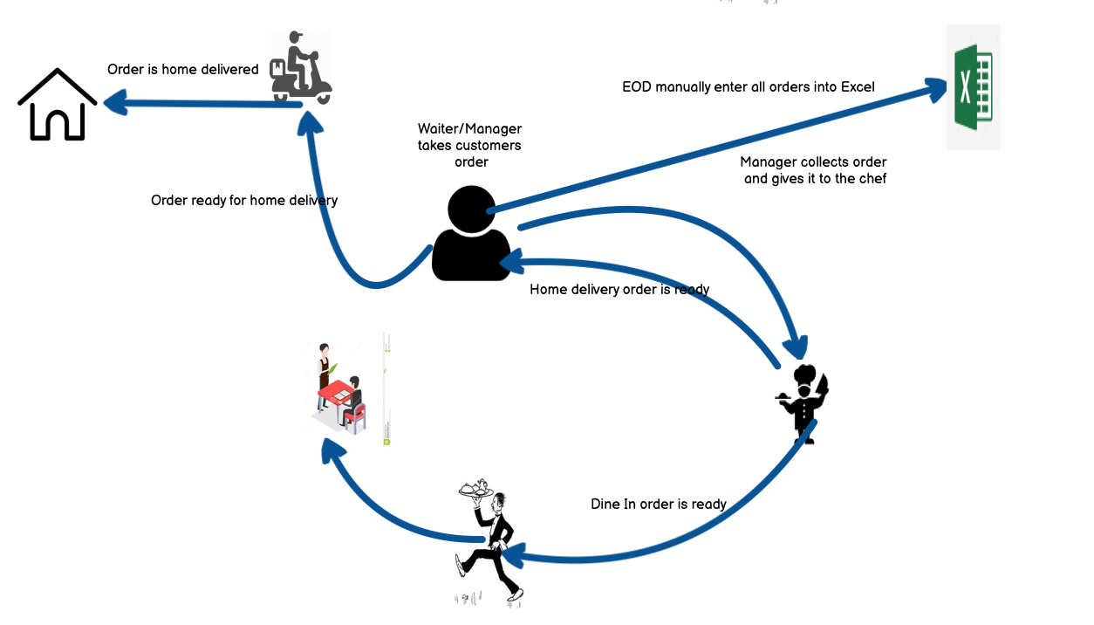

*Figure 4: Current State Process*

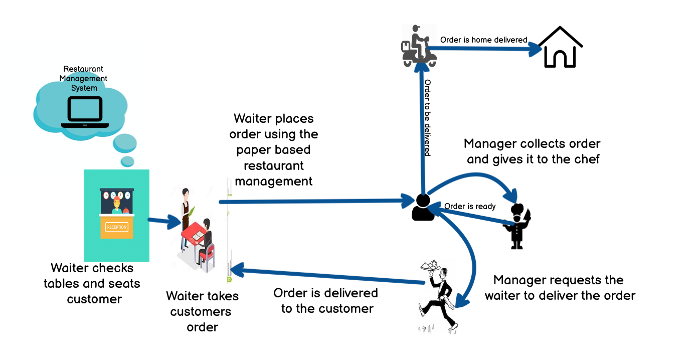

*Figure 4: Future State Process*

***Process Modelling***

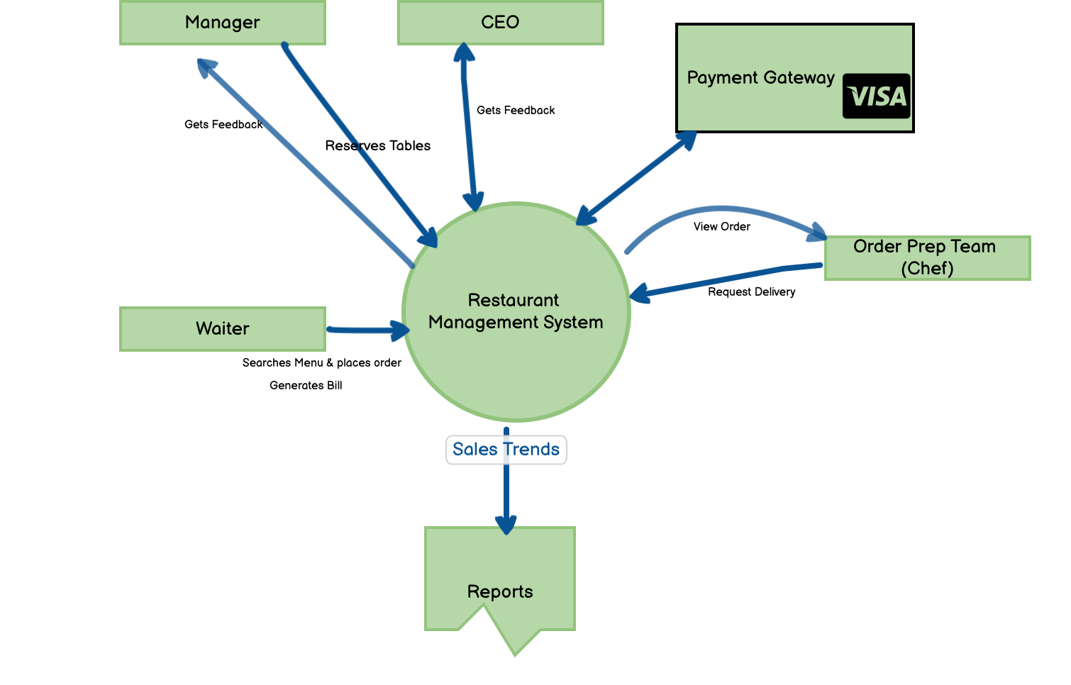

*Figure 6: Process Modelling using Use case Diagram (UML)*



















*Figure 7: Product Verification & Validation Model*

#### Scope Modelling

*Table 4: High-level Components that needs to be built*

|  |  |  |
| --- | --- | --- |
| **User Roles** | **Components / Features** | **Authorization** |
| Waiter |  |  |
| Menu List | View |
| Feedback Form | View |
| Order Meal | View, Edit |
| Order Status | View |
|  | Table reservation | View |
| Restaurant Manager | Menu List | View, Add, Edit |
| Feedback Form | View, Add |
| Order Meal | View |
| Order Status | View, Edit |
| Group Orders by Menu Items | View |
| Request Delivery | Edit |
|  | Table reservation | View, Edit |
| Order Prep Team | Order Status | View |
| Order Status | View |
| CEO | Reports | View |

*Table 2: Product In-scope & Out of Scope*

|  |  |
| --- | --- |
| **In-scope** | **Out of Scope** |
| View Menu | Prepaid Payment |
| Order Meal |  |
| View Order |  |
| Edit Order |  |
| View Order Status | Request for Inventory and Supplier |
| Order Delivery to the Customer |  |
| Payment Gateway |  |
| Create / Update Menu |  |
| Table selection/Reservation |  |
| Generate Bill |  |
| Customer Feedback/Comments |  |
| Reports/Data |  |

#### Data Modelling:

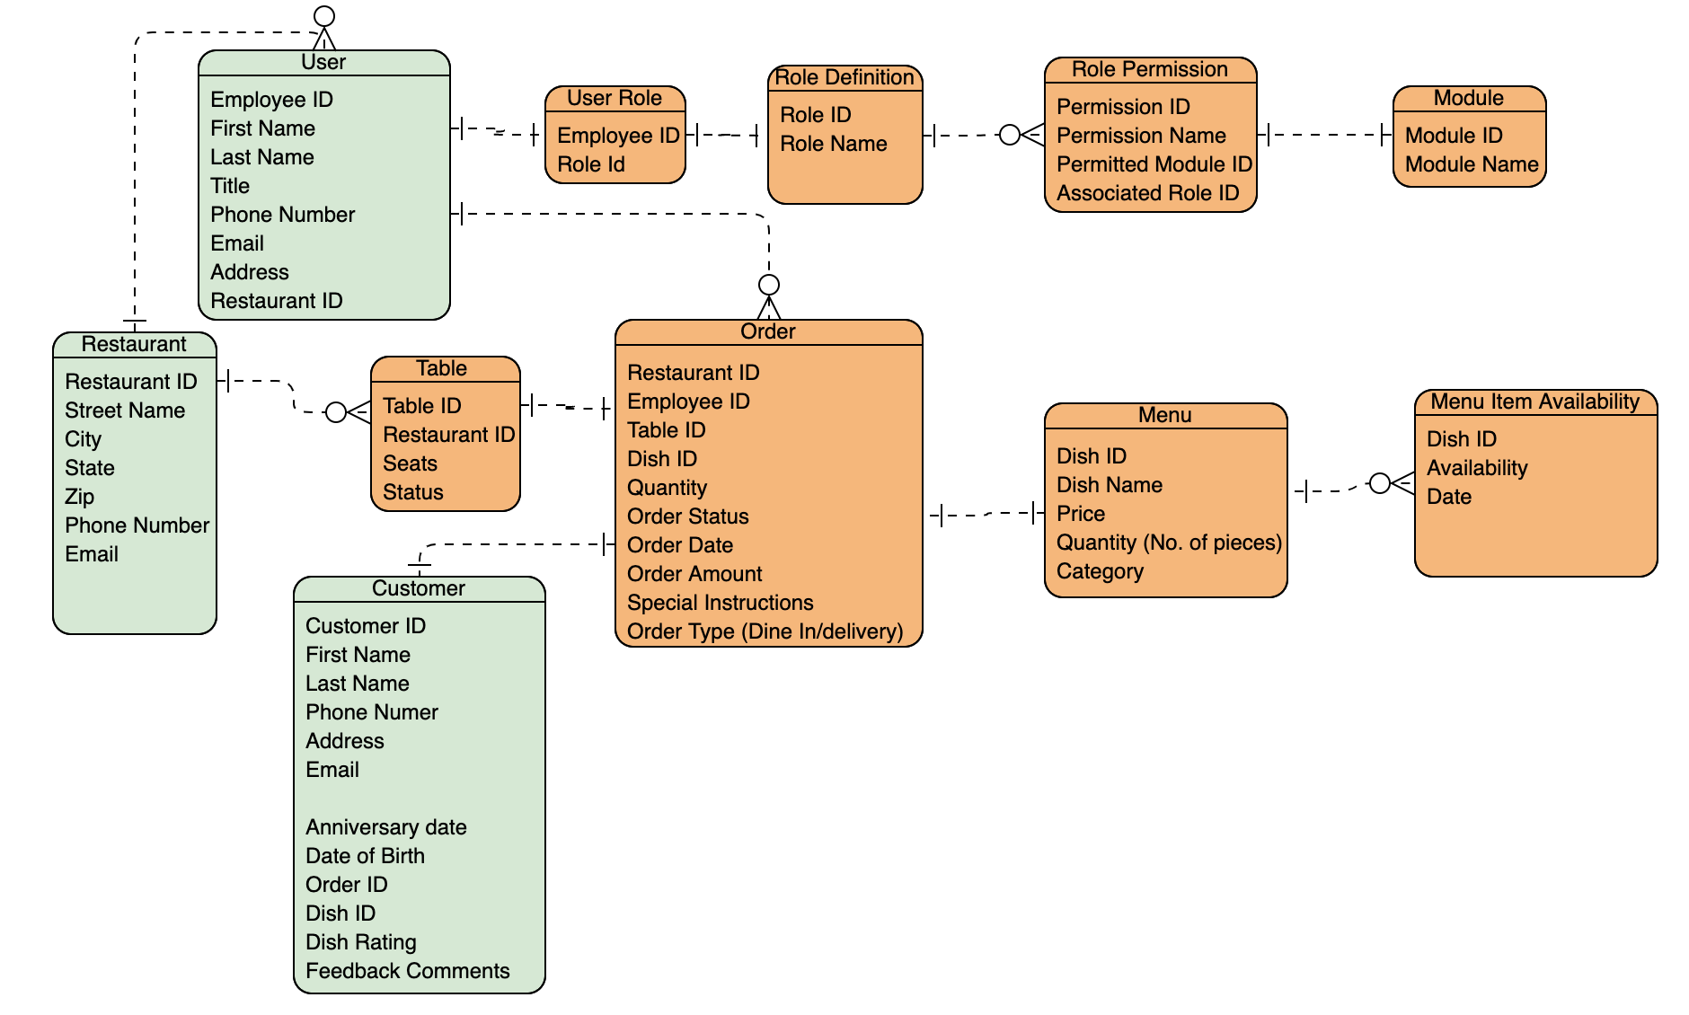

*Figure 8: Data Modelling using ER Diagram*

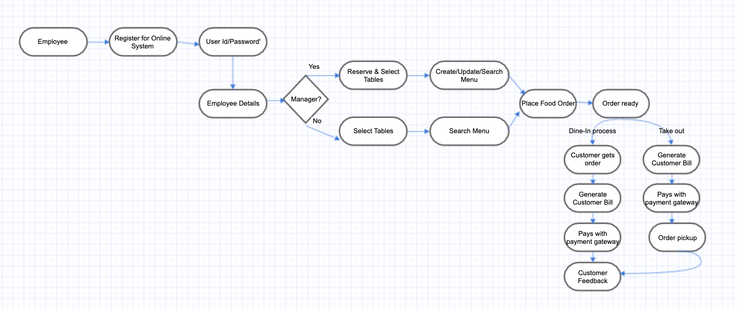

***Swimlane Activity Diagram:*** The Diagram employs the swim lanes to show the responsibility or synchronization bar to represent the parallel processes in multiple areas. Here the activity of ordering the food online represent how the data flows through the lanes.

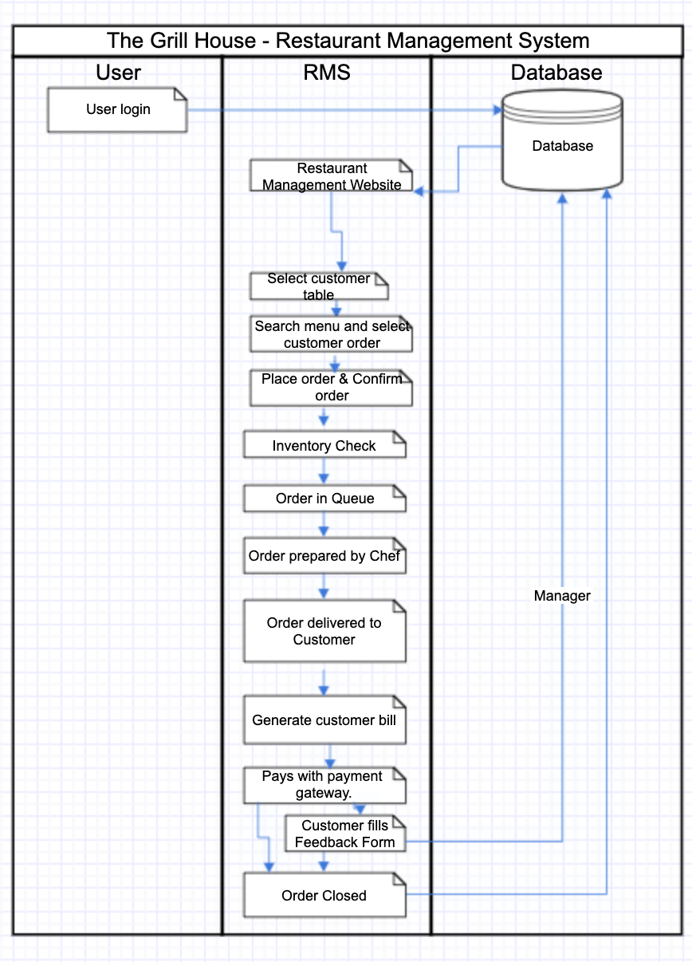

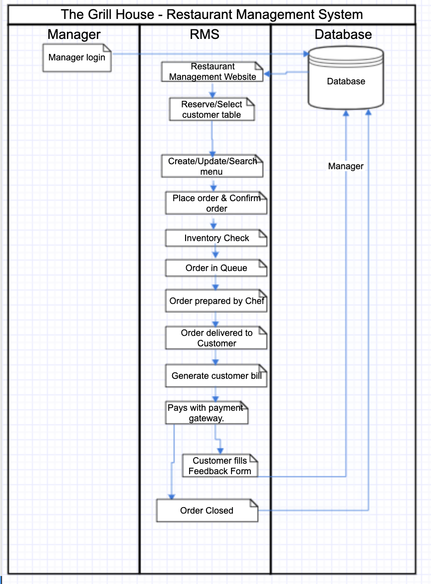

***Wireframe for the Online Restaurant Management System:***

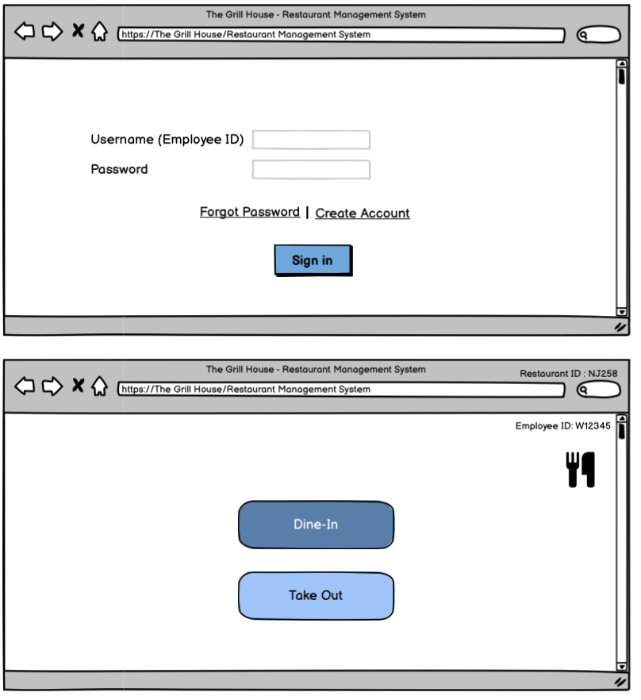

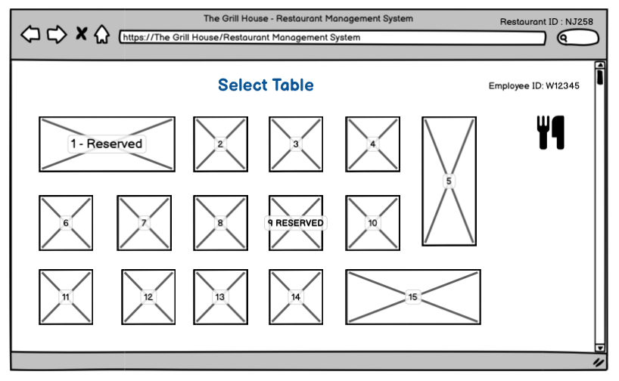

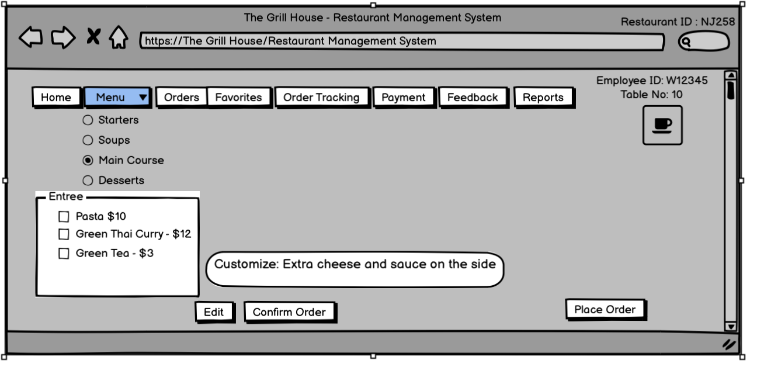

***Conclusion:*** The Online Restaurant Management System should achieve the business objectives on release.

**Business Objective 1:** Improved management of the restaurant chains by allowing access to the managers to update menu, make take reservations and keep track of sales. Waiters can place orders based on the most current menu and bill customers with accuracy.

 Scale: Value is quality of service and time saving.

* Previous – paper-based bills

**Business Objective 2:** Reduced restaurant operating costs by 15% within 6months, following initial release.

**Business Objective 3:** Increased average effective work time by 30 minutes per waiter per day, and increased manager work time by 1 hour within 3 months.

**Business Objective 4:** The reports will be generated faster due to information being available immediately and this will help in knowing the sales trends to make better planning and menu decisions.

**Business Objective 5:** The management can make better decisions with customer feedback.

#### **Product Backlog**

|  |  |  |  |  |  |
| --- | --- | --- | --- | --- | --- |
| Title | State | Backlog Priority | Story Points | Acceptance Criteria | Iteration Path |
| As a user I want to create an account so that I can use the Restaurant Management system. | Approved | 9 | 2 | Given that the user has access to the application. If the user is a valid employee (waiter, manager or other) then the account can be created otherwise display “Account cannot be created”. | Release 1- Sprint 1 |
| As a user I want to change password so that I can reset it. | Approved | 9 | 1 | A user is able to change password when he enters his old password and is allowed to create a new password. When the new password is entered it should be 8 characters long and it should have 1 character, 1 number and 1 special character. | Release 1- Sprint 1 |
| As a waiter I want to search the menu so that I can lookup dishes and prices. | Approved | 5 | 4 | When on the application the user is able to locate search. The user enters any value and the value will be displayed. | Release 1- Sprint 1 |
| As a manager I want to add new items, delete existing items, as well as create new menus from scratch so that the menu is accurate. | Approved | 3 | 5 | When the manager is on the application, they should be able to locate the Menu. They can add, delete or edit any items and prices on the menu. | Release 1- Sprint 1 |
| As a waiter I want system access so that I can place customer order. | Approved | 3 | 2 | When on the application the waiter should be able to locate the order menu and select dishes to place the customer order. | Release 1- Sprint 2 |
| As a waiter I want system access so that I can generate bills table wise. | Approved | 4 | 2 | When on the application the waiter should be able to locate the bill option and generate the bill. | Release 1- Sprint 2 |
| As a waiter I want to generate the bill tagged to me (the waiter generating it) and the table number so that it can be tracked. | Approved | 4 | 2 | When on the application the waiter should be able to select the table so that both table name and waiter id is on the generated bill. | Release 1- Sprint 2 |
| As a manger I want to reserve tables so that they can be booked. | Approved | 7 | 3 | When the manger is on the application, he can select tables and reserve them for customers. | Release 1- Sprint 3 |
| As a waiter I want to look into the software to determine which tables need to be reserved so that I can seat dine in customers. | Approved | 6 | 2 | When on the application the waiter should be able to search for tables available and select the table to seat customers. | Release 1- Sprint 3 |
| As a waiter or manager, I want to access to payment gateway on the system so that customers can pay by cash or card. | New | 4 | 4 | When the user is on the application they can take customer payments by cash or credit card using the payment gateway. | Release 1- Sprint 3 |
| As a CEO I want feedback form given to every customer so that details like name, address, mobile number, email, date of birth, anniversary dates of the customers, and their feedback can be captured. | New | 5 | 4 | When on | Release 1- Sprint 3 |
| As a manager I want to manually enter customer details like name, address, mobile number, email, date of birth, anniversary dates and their comments so that the customer feedback & information can be stored in the system. | New | 6 | 4 | When on the application as a manager I should be able to locate the feedback form for printing and be able to enter the information from the feedback form into the system. | Release 1- Sprint 4 |
| As Management I want reports on sales trends at the EOD so that decisions can be made. | New | 3 | 8 | When on the application the management should be able to generate reports showing sales trends. | Release 1- Sprint 4 |